

Concept of Operations

True North

Version: 1.0

Date: August 2022

Revision History

|  |  |  |  |  |  |  |
| --- | --- | --- | --- | --- | --- | --- |
| **Rev** | **Date** | **Comment** | **Author** | **Reviewer** | **Approver** | **Approval Date** |
| original | August 2022 |  | True North SWG | Anthony MacKay | CPAAT |  |
|  |  |  |  |
|  |  |  |  |
|  |  |  |  |  |  |  |
|  |  |  |  |
|  |  |  |  |
|  |  |  |  |  |  |  |
|  |  |  |  |
|  |  |  |  |
|  |  |  |  |  |  |  |
|  |  |  |  |
|  |  |  |  |
|  |  |  |  |  |  |  |
|  |  |  |  |
|  |  |  |  |
|  |  |  |  |  |  |  |
|  |  |  |  |
|  |  |  |  |
|  |  |  |  |  |  |  |
|  |  |  |  |
|  |  |  |  |

Table of Contents

1. ConOps Introduction 6

1.1. ConOps Objective 6

1.2. ConOps Background 6

1.3. ConOps Scope 7

1.4. ConOps Approach 7

2. Current Operational Situation 8

2.1. Background on Earths Magnetism 8

2.2. ICAO SARPs and PANS 9

2.3. Canadian Aviation Regulations 11

2.4. Description of Canadian Domestic Airspace 12

2.5. Description of Current Operations in Canadian Southern Domestic Airspace 13

2.6. Description of Current Operations in Canadian Northern Domestic Airspace 14

2.7. Magnetic Variation Challenges and Opportunities 16

3. Proposed System 18

3.1. Overview of the Proposed System 18

3.2. Assumptions and Dependencies 18

3.3. Other Considerations 18

4. Operational Scenarios 19

4.1. Aircraft that have an AFM option or AFM supplement certified and available to allow navigation systems to operate in either True or Magnetic 19

4.2. Aircraft that do not have an AFM option or AFM supplement certified and available rendering navigation systems incapable of operating in True 22

4.2.1. Aircraft that are inertial equipped but do not currently have means to bypass mag var tables 22

4.2.2. Aircraft with a gyro-magnetic compass 22

4.2.3. Aircraft with Directional Gyros manually reset to a Direct Reading Compass 24

4.2.4. Aircraft with a Direct Reading Compass only 25

5. Operational Impacts 26

6. Financial Impacts 28

6.1.1. Aircraft Operators 28

6.1.2. Airport Operators 28

6.1.3. Air Navigation Service Providers 32

6.1.4. Avionics Original Equipment Manufactures 33

6.1.5. Aircraft Manufactures 33

6.1.6. ICAO 33

6.1.7. State Regulators 33

6.1.8. Aviation Database suppliers 33

7. Requirements 34

7.1. Canadian Regulatory Requirements 34

7.2. Domestic ANSP/ATM Requirements 34

7.3. Adjacent ANSP/ATM Requirements 34

7.4. Transition Requirements Between True/Magnetic Airspace 34

7.5. Communication, Navigation and Surveillance Requirements 35

7.6. Airspace Requirements 35

7.7. Airport Requirements 35

7.8. Publication requirements 36

7.9. Weather Reporting Requirements 36

7.10. Customer/Stakeholder Requirements 37

7.11. Other External Stakeholder Requirements 37

7.12. International/ICAO Requirements 37

8. Analysis of Proposed System 38

8.1. Summary of Advantages 38

8.2. Summary of Disadvantages or Limitations 39

9. Appendices 41

Table of Figures

Figure 1 – Magnetic and True poles 8

Figure 2 – Canadian Domestic Airspace 13

Figure 3 – Northern Domestic Airspace 15

Figure 4 – Inertial reference unit True operation area 16

Figure 5 – Magnetic/True selection 20

Figure 6 – Magnetic Variation in Canada 36

# ConOps Introduction

Aviation has used magnetic north since the earliest days of flight. As soon as aircraft were developed, a heading reference system was required that needed to be small, lightweight and simple - a magnetic compass was fitted to almost every aircraft.

As navigation systems developed, a heading instrument or directional gyro was used to account for small errors in the magnetic compass caused by dips in the Earth’s magnetic field. Periodically, the pilot would reset the heading instrument to align with the magnetic compass.

In the jet age, the heading instrument was tied to a magnetic sense system eliminating that one step of the pilot reading the magnetic compass and then setting the heading instrument.

After the 1980s and onwards as aircraft systems became more tightly integrated and digital systems developed, small magnetic variation errors have become more than a mere distraction, driving a mismatch between the various navigation systems.

Eliminating aviation’s use of magnetic north could be financially beneficial to all aviation segments over the coming years.

## ConOps Objective

This Concept of Operations (ConOps) will lay out the concept for how Canada could expand the use of True North azimuth currently used in Northern Domestic Airspace to both Northern and Southern Domestic Airspace.

## ConOps Background

The International Association of Institutes of Navigation (IAIN) authored a paper for the 2020 European navigation Conference titled “Changing from Magnetic to True Tracks in Aviation”. The paper states: *The biggest single problem in trying to implement this change worldwide would be inertia – the large number of countries involved and the difficulty of finding the will to all change at once. Some of these countries do not have a sophisticated aviation environment that could deal with this easily, and in others, such as the United States, the sheer extent of the change would be formidable and might meet opposition from a conservative general aviation lobby. A foreseeable way that it could happen would be if a single country were to file a difference with ICAO and change unilaterally. Once they had proved that it worked without problems, we might then expect others to follow progressively.*

Since Canadian Northern Domestic Airspace already operates using True tracks, Canada was considered a possibility for early implementation. On June 10th, 2020 the Canadian Performance-based Aviation Action Team (CPAAT) formed a working group to investigate expanding use of True North in Canada. This ConOps is the result of that investigation.

## ConOps Scope

The scope of this ConOps includes all topics related to the technical and/or cost path that would allow expanding the use of True North across all of Canadian Domestic Airspace.

Items outside the scope of this ConOps include:

* aspects not directly affecting the proposed Canadian system
* issues regarding change to aircraft certification
* changes required to publications of the International Civil Aviation Organization (ICAO)
* implementation planning, including any hazard identification and risk assessment activities (once the ConOps is approved, a detailed plan for implementation would be produced)

## ConOps Approach

This ConOps will discuss the current operational situation regarding the use of True and magnetic tracks, introduce a proposed system, explain the operational scenarios, outline operational as well as cost impacts, and present a list of requirements should the operational concept receive approval. Once the ConOps document is complete, it will be presented to the Canadian Performance-based Aviation Action Team (CPAAT).

In order to determine the operational and cost impacts, stakeholders requested a proposed date of implementation. Purely for the purpose of developing the impacts sections of this ConOps document, it was agreed to estimate the year 2030 for implementation.

# Current Operational Situation

True direction remains constant with time, can be established by measuring the spin of the Earth and offers operating accuracy of the order of one tenth of a degree. Magnetic declination (otherwise known in aviation as magnetic variation) changes with location and time, necessitating constant updating of published procedures.

## Background on Earths Magnetism

The traditional simple model used to visualise the Earth’s magnetic field is to imagine a straight bar magnet running through the Earth. Unfortunately, this is a gross simplification as much of the Earth’s magnetism is caused because the outer core of the Earth is a mass of molten metal containing a significant amount of ferrous ores. The combination of the rotation of the Earth and the convection currents within this liquid makes up the main component of the magnetic field. The remainder of the earth’s magnetic field comes from local magnetic anomalies caused by deposits of solid mineral, mainly magnetite, nearer the surface of the Earth.

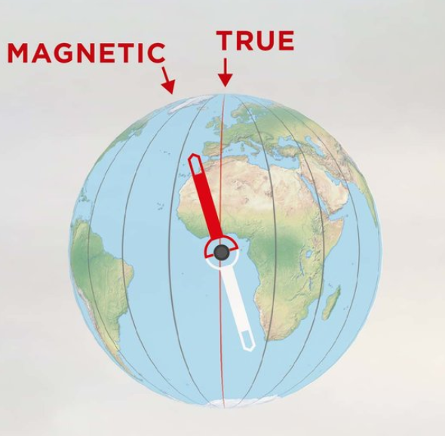

Figure 1 – Magnetic and True poles

Magnetic variation is the angle between True north and local magnetic north. Magnetic variation charts are issued regularly by several geodetic organizations.

It is unknown what causes variation to change and attempts to model the changing pattern have largely been unsuccessful. All that can be done is to observe what has happened in the past and extrapolate into the near future. Like weather modelling, the further the prediction extends the less accurate the model becomes. This becomes problematic for extended magnetic variation tables (10-15 years) loaded in some aircraft or on tables that only contained 5 years and have long expired. The ANSP updates their model every 5 years.

The North and South magnetic poles are not co-located with the True poles, as defined by the extremities of the Earth’s spin axis, nor are they antipodal. For instance, in 2015 the North magnetic pole was at approximately N87° W150°, whilst the South magnetic pole was at around S65° E137° – so far away from the True South pole that it is not even on the continent of Antarctica.

More importantly, these magnetic poles are constantly moving. For example: at Oxford Airport in the United Kingdom, the variation in 1942 was 11°W. In 2015 it was about 1°W. So, it had changed 10° in approximately 73 years, giving an overall rate over that period of one degree every 7.3 years. In other parts of the world the rates of change are different, and how fast these rates of change are speeding up or slowing down is also different.

There are also parts of the world where it is impossible to use a magnetic compass at all. Near the poles, the lines of flux of the earth’s magnetic field lie at a very steep angle to the earth’s surface. The scientific term for this is inclination, but it is normally called the ‘angle of dip’ by aviators. Close to the poles, the horizontal component drops to less than 6 microteslas, which is the generally accepted figure for the threshold below which a magnetic compass can no longer be used.

## ICAO SARPs and PANS

The International Civil Aviation Organization (ICAO) has adopted Standards and Recommended Practices (SARPs) for Contracting States to use for civil aviation operations and has incorporated them as Annexes to the Convention on International Civil Aviation.

ICAO SARPs generally permit Contracting States to determine the most appropriate means for calculation of azimuth. For example, Heading and Track are frequently referenced in the SARPs, for which ICAO has assigned the following definitions:

***Heading.*** *The direction in which the longitudinal axis of an aircraft is pointed, usually expressed in degrees from North (true, magnetic, compass or grid).*

***Track.*** *The projection on the earth’s surface of the path of an aircraft, the direction of which path at any point is usually expressed in degrees from North (true, magnetic or grid).*

As well as these definitions, multiple SARPs identify how Contracting States are expected to apply azimuth. For example, Annex 14, Volume I, Chapter 5, paragraph 5.2.2.4 reads:

*A runway designation marking shall consist of a two-digit number and on parallel runways shall be supplemented with a letter. On a single runway, dual parallel runways and triple parallel runways the two-digit number shall be the whole number nearest the one-tenth of the magnetic North when viewed from the direction of approach. On four or more parallel runways, one set of adjacent runways shall be numbered to the nearest one-tenth magnetic azimuth and the other set of adjacent runways numbered to the next nearest one-tenth of the magnetic azimuth…*

Article 38 of the convention requires that a Contracting State notify ICAO any time it does not comply with a Standard in all respects, it does not bring its regulations or practices into full accord with any Standard, or it adopts regulations or practices differing in any particular respect from the Standard. This is referred to as filing a Difference.

Due to Canada’s use of True azimuth in Northern Domestic Airspace, Canada has already filed a Difference for the SARPs that identify use of magnetic azimuth. Canada’s Difference filed regarding Annex 14, Volume I, Chapter 5, paragraph 5.2.2.4 reads:

*Runways within Canadian Northern Domestic Airspace are designated with reference to the True azimuth because magnetic compasses are unreliable in the area.*

ICAO also publishes Procedures for Air Navigation Services (PANS), containing operating practices as well as material considered too detailed for SARPs. The PANS augment the basic principles in the corresponding SARPs. While not mandatory, ICAO encourages States to file Differences to PANS the same way they do for SARPs.

The PANS for Aeronautical Information Management (PANS AIM – Doc 10066) identifies how States should organize their Aeronautical Information Publication (AIP). In the ENR section, under Air Traffic Service (ATS) Routes, the PANS AIM includes the following:

*Bearings, tracks and radials are normally magnetic. In areas of high latitude, where it is determined by the appropriate authority that reference to Magnetic North is impractical, another suitable reference, i.e. True North or Grid North, may be used.*

Canada has again filed a number of Differences to PANS AIM, such as the following:

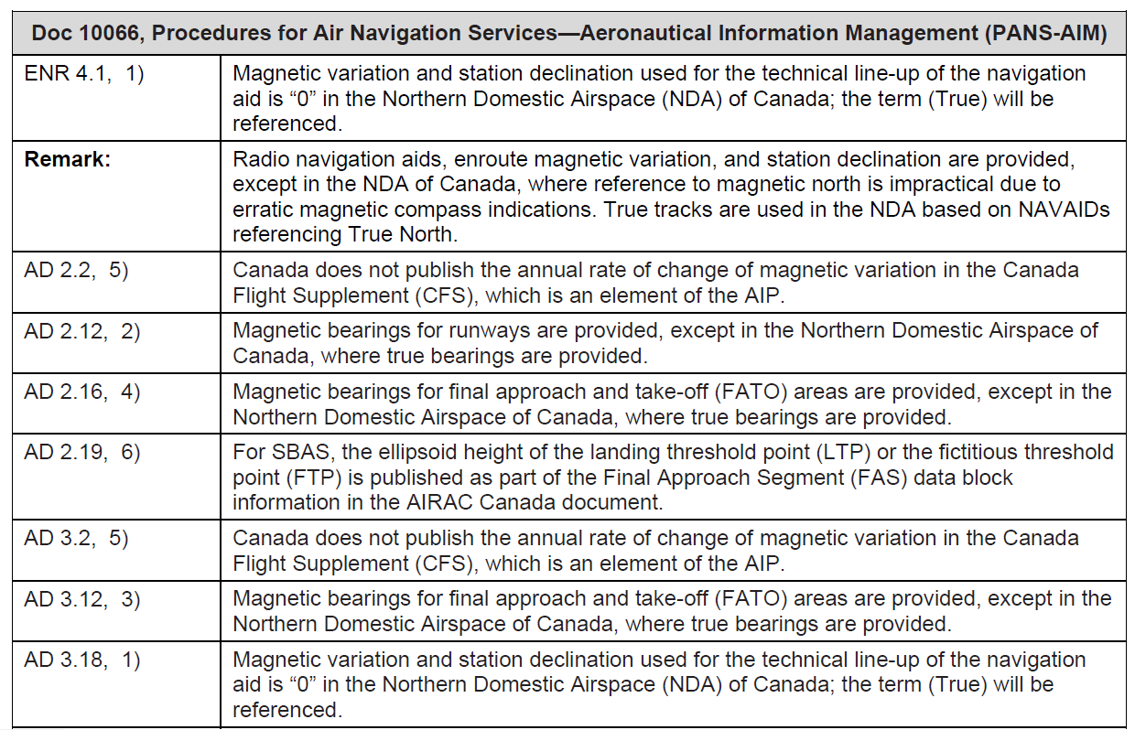

Canada has filed differences to other SARPs and PANS, such as wind direction observations for landing and takeoff since we use degrees True in Northern Domestic Airspace.

## Canadian Aviation Regulations

The Canadian Aviation Regulations (CAR) definitions for heading and track contain similar azimuth allowances as publishes in the ICAO SARPs:

**heading***means the direction in which the longitudinal axis of an aircraft is pointed, usually expressed in true, magnetic or grid degrees from North; …*

**track***means the projection on the earth’s surface of the path of an aircraft, the direction of which path at any point is usually expressed in true, magnetic or grid degrees from North; …*

In addition to the CAR definitions, other sections of the CAR identify either Magnetic or True track requirements, or aircraft equipment requirements:

**602.34** (1) The appropriate cruising altitude or cruising flight level for an aircraft in level cruising flight is determined in accordance with:

(a) the magnetic track, in the Southern Domestic Airspace; and

(b) the true track, in the Northern Domestic Airspace.

**605.14** No person shall conduct a take-off in a power-driven aircraft for the purpose of day VFR flight unless it is equipped with…

(d) a magnetic compass or a magnetic direction indicator that operates independently of the aircraft electrical generating system; …

**605.15** (1) No person shall conduct a take-off in a power-driven aircraft for the purpose of VFR OTT flight unless it is equipped with…

(d) a gyroscopic direction indicator or a stabilized magnetic direction indicator; … [and]

(g) where the aircraft is to be operated within the Northern Domestic Airspace, a means of establishing direction that is not dependent on a magnetic source; …

**605.16** (1) No person shall conduct a take-off in a power-driven aircraft for the purpose of night VFR flight, unless it is equipped with…

(f) where the aircraft is operated so that an aerodrome is not visible from the aircraft, a stabilized magnetic direction indicator or a gyroscopic direction indicator; [and]

(g) where the aircraft is to be operated within the Northern Domestic Airspace, a means of establishing direction that is not dependent on a magnetic source; …

**605.19** No person shall conduct a take-off in a balloon for the purpose of day VFR flight unless it is equipped with…

(d) in the case of a captive gas balloon, a magnetic direction indicator; …

**605.21** No person shall operate a glider in day VFR flight unless it is equipped with…

(c) a magnetic compass or a magnetic direction indicator; …

**604.60** No person shall file a flight plan indicating that an aircraft operated by a private operator can be operated in accordance with area navigation 1 (RNAV 1) or area navigation 2 (RNAV 2) requirements unless…

(b) every flight crew member has received RNAV 1 or RNAV 2 training, for which the validity period has not expired, in

(v) the operation of the area navigation system in a compass unreliability area, …

## Description of Canadian Domestic Airspace

Canadian Domestic Airspace includes all airspace over the Canadian land mass, the Canadian Arctic, Canadian Archipelago and those areas of the high seas within the airspace boundaries depicted in the following figure. Canadian Domestic Airspace is then sub-divided into Southern Domestic Airspace and Northern Domestic Airspace; each of which have different operating practices related to use of the compass.

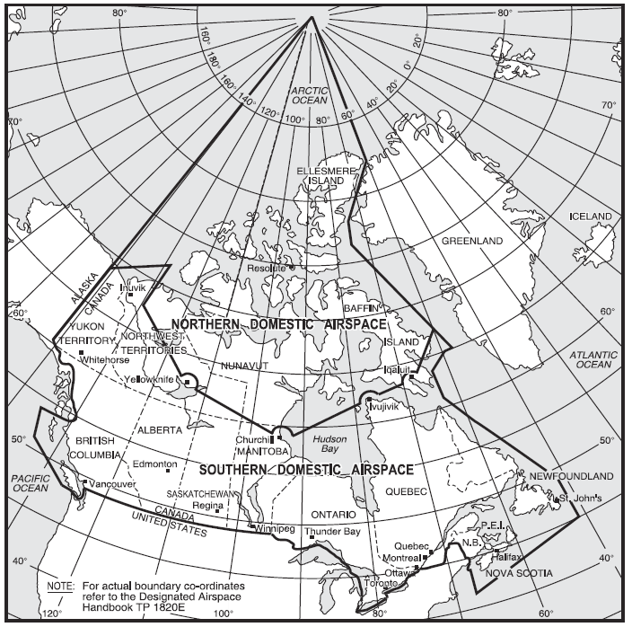

Figure 2 – Canadian Domestic Airspace

## Description of Current Operations in Canadian Southern Domestic Airspace

In the Canadian Southern Domestic Airspace, magnetic track is used to determine cruising altitude for direction of flight. Magnetic azimuth is also used as the datum for instructions, procedures and control, approach procedure tracks and runway numbering.

Runway numbering is determined by rounding the magnetic runway centreline, upwards or downwards, to the nearest ten degrees, then expressing the result as a 2-digit figure. 195°, for instance, rounded upwards, becomes 200°, or Runway 20, whilst 194° is rounded downwards to 190°, or Runway 19. Changes can necessitate re-painting the large white numerals on the main runways, in some cases closing the aerodrome while the work is in progress.

Another application in which magnetic north is used as a datum are ground-based navigation aids where the bearing information is incorporated at the ground station, that is: Very High Frequency Direction finding (VDF), Very High Frequency Omni Range (VOR) and military Tactical Air Navigation (TACAN) systems.

In Canadian Southern Domestic Airspace, magnetic variation on procedures is maintained as follows:

* Instrument Landing Systems (ILS), Non-Directional Beacons (NDB) maintained within ±2°
* ILS Category II/III maintained within ±1°
* PBN and NDB Airways/routes maintained within ±2°
* PBN and NDB Instrument approach procedures maintained within ±2°
* VOR and TACAN technical alignment maintained within ±3° for enroute airways/routes and approach
* Secondary Surveillance Radar (SSR), Automatic Dependent Surveillance – Broadcast (ADS-B) and Muti-Lateration (MLAT) are maintained in accordance with magnetic variation tables reference date and time.

## Description of Current Operations in Canadian Northern Domestic Airspace

The magnetic North Pole is located within Northern Domestic Airspace, therefore magnetic compass indications may be erratic. In this airspace, runway heading is given in True and True track is used to determine cruising altitude for direction of flight in lieu of magnetic track.

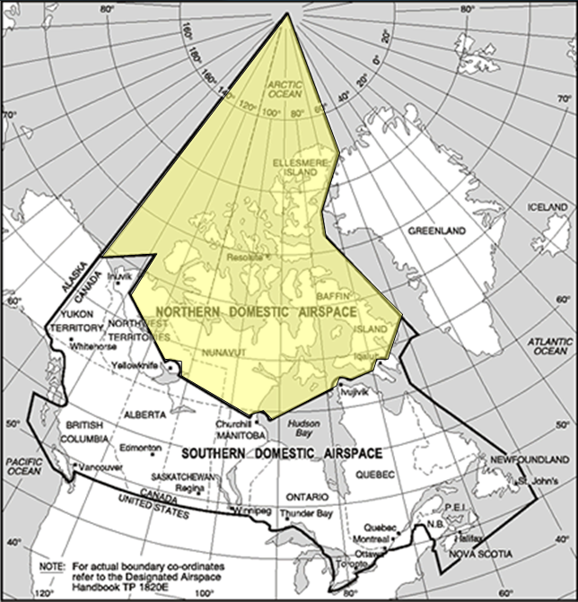

Figure 3 – Northern Domestic Airspace

In Northern Domestic Airspace all navigation aids including Instrument Landing Systems (ILS), Very High Frequency Omni Range (VOR), military Tactical Air Navigation (TACAN) systems and Non-Directional Beacons (NDB) are set to True and use 0 degrees declination with conventional ground-based airways as well as fixed area navigation (RNAV) routes referenced to True. In Northern Domestic Airspace NAV CANADA designs Performance-Based Navigation (PBN) airport procedures with Localizer Performance with Vertical guidance (LPV), Lateral/Vertical Navigation (LNAV/VNAV) and LNAV minima as well as Required Navigation Performance (RNP) Authorization Required (AR) procedures with reference to True North.

Additionally, the variation correction system in inertial reference units and flight management systems is not available at high latitudes. Manufacturers accept that, near the poles, the value of variation is so high and the rate of change so great that it would be unusable and therefore unsafe to make it available. The magnetic database is inhibited at these latitudes and aircraft operate in True. This area is depicted in the figure below.

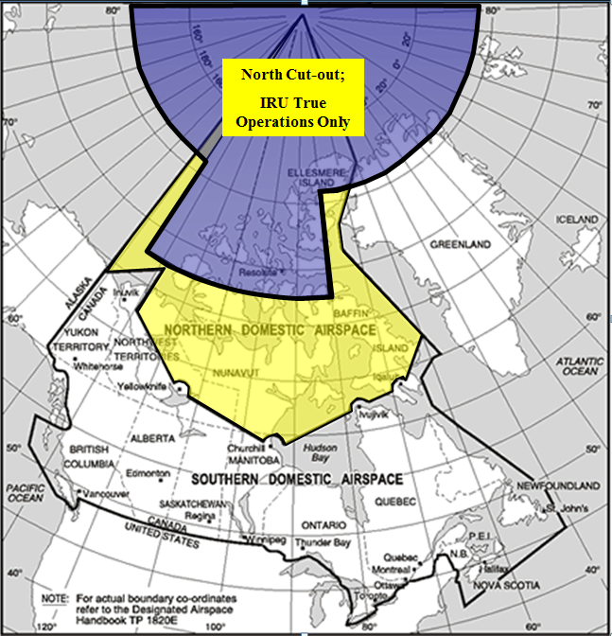

Figure 4 – Inertial reference unit True operation area

## Magnetic Variation Challenges and Opportunities

Ten years ago in Anchorage, Alaska in 2012, the Federal Aviation Administration (FAA) updated the magnetic variation of the airport and approaches to reflect current values. This caused a mismatch between the magnetic variation used in various aircraft systems and the navigation database in flight management systems. As a result, some aircraft experienced unacceptable lateral guidance when conducting ILS Category II/III approaches. To rectify the problem, the FAA returned the magnetic variation to the incorrect, but usable value from the aircraft perspective, until the aircraft operators could update their inertial reference unit magnetic variation tables. Essentially the headings provided by the inertial reference units were “arguing” at a computer systems level with the aircraft autoflight system resulting in the aircraft rolling back and forth when tracking the localizer signal.

In another incident, aircraft operators with inertial reference units for heading data were experiencing unstable ILS Category II/III approaches at Canadian airports in their aircraft. Upon investigation it was discovered that the aircraft magnetic variation tables were ten to fifteen years out of date. It is not known what the status is of other air operators worldwide with their magnetic variation tables, but each operator is provided with information from their inertial reference unit or aircraft manufacturer on their magnetic variation status and each operator has to determine how it affects their operation. From this, air operators either update their avionics with current mag var tables or manage the errors through operational restrictions. States have issued airworthiness directives for some aircraft types (notably CRJ series aircraft and the BAE RJ85) restricting operations. Manufactures issue magnetic variation notices for their aircraft restricting operations until magnetic variation tables are updated. Some aircraft and systems do not have a path to update to current magnetic variation tables.

With incorrect heading information, synthetic runways generated by head-up displays and synthetic vison guidance systems do not overlay the real runway.

With incorrect magnetic variation information, approach tracks displayed in flight management systems will vary from what is charted until the leg becomes active, when it uses the procedure design magnetic variation instead of the aircraft system (IRU or FMS base map) magnetic variation.

Aircraft will fly incorrect headings under vector to final operations. Depending on the system architecture, a stable intercept to final may be delayed (waffling) until the aircraft can sort out the difference between the heading the Course Deviation Indicator (CDI) is set to and the guidance being received from the flight management system while the capture mode is active.

The World Magnetic Model is a joint product of the United States’ National Geospatial-Intelligence Agency (NGA) and the United Kingdom’s Defence Geographic Centre (DGC). The World Magnetic Model is the standard model used by the U.S. Department of Defense, the U.K. Ministry of Defence, the North Atlantic Treaty Organization (NATO) and the International Hydrographic Organization (IHO), for navigation, attitude and heading referencing systems using the geomagnetic field. It is also used widely in civilian navigation and heading systems. The model is typically produced at 5-year intervals (EPOCH), with the current model expiring on December 31,2024.

Magnetic variation has begun to change more rapidly. Typically, a new version of the World Magnetic Model is released every five years. In 2019, due to un-forecast variations in the Arctic region, a new model had to be released ahead of schedule to more accurately represent the change of the magnetic field. This out-of-cycle update was issued to ensure safe navigation for military applications, commercial airlines, search and rescue operations, and others operating around the North Pole. The 2015 World Magnetic Model forecast was no longer deemed to be valid until 2020.

# Proposed System

## Overview of the Proposed System

The case for converting to True as the datum for aviation instructions, procedures and surveillance is clear, and the only problems would be those of practically implementing it. Whilst it would be a large-scale undertaking, it would also be a one-off operation which, once completed, would be final, unlike the present situation which is also costly and constantly with us requiring resources to manage.

The proposed system would use True azimuth for aviation operations in both Northern and Southern Canadian Domestic Airspace.

## Assumptions and Dependencies

Three major dependencies affect the proposed system:

* The capability of aircraft/pilots from Canadian Southern Domestic Airspace to navigate in True like they do in Northern Domestic Airspace
* The capability of airports in Canadian Southern Domestic Airspace to re-designate runways using True azimuth
* The capability to manage issues with adjacent Air Navigation Service Providers/Air Traffic Management systems and how the point of transition between True and magnetic is handled.

## Other Considerations

Other considerations include:

* The ability of third-party chart and database providers to complete a large one-time change of heading reference in Canada’s AIP
* Timing of the change
* Freezing of current procedures in a defined period leading up to the change to allow NAV Canada and Airports to focus on the change to True North alone.
* Advise to third party IAP design organizations

# Operational Scenarios

The following operational scenarios describe the conditions and context under which the proposed system will operate. It must be noted that the entire system will operate in True, not just aircraft heading. All ATM and aircraft components will be operating in True. All reported weather is currently produced in True with the only exception being reported wind for take-off and landing (including ATIS and most D-ATIS). The entire system is expected to operate without pilot input for magnetic to true conversion except for those pilots operating light aircraft with manually set directional gyros.

It is expected that aircraft fall into one of two main categories: aircraft that have an Aircraft Flight Manual (AFM) option or AFM supplement certified and available to allow navigation systems to operate in either true or magnetic, and aircraft that do not currently have an AFM option or AFM supplement certified and available allowing aircraft operations with reference to True.

## Aircraft that have an AFM option or AFM supplement certified and available to allow navigation systems to operate in either True or Magnetic

Some aircraft have an AFM option or AFM supplement certified and available which allows, or would allow, the installed navigation systems to operate in either True or Magnetic. On some aircraft that capability may be selectable through the Flight Management System (see figure 5), while on other aircraft a separate selector may be offered to allow the flight crew to switch between magnetic and True (see figure 6).

Many air transport aircraft that have inertial reference units could also switch to True with an aircraft switch selection or one-time software change. The IRS internally works in True heading and algebraically adds computed magnetic variation from a magnetic variation topographical map to True heading producing magnetic heading. The IRS heading is then displayed on the cockpit heading displays. The displayed heading may be True or magnetic depending on the selected heading mode (TRUE or MAG). In addition, the magnetic variation map does not cover the entire earth and in areas not covered by the magnetic variation map, the IRS will output only True heading. When entering areas not covered by the magnetic variation map, the flight crew may have to manually select TRUE if not automatically selected.

If the onboard navigation systems have the capability to switch between magnetic and True, or if an aircraft supplement is available which would permit such a selection, there would be limited operational impact for these aircraft if Canada adopted True azimuth across all of Canadian Domestic Airspace.

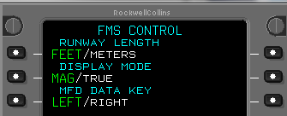

Figure 5 – Magnetic/True selection

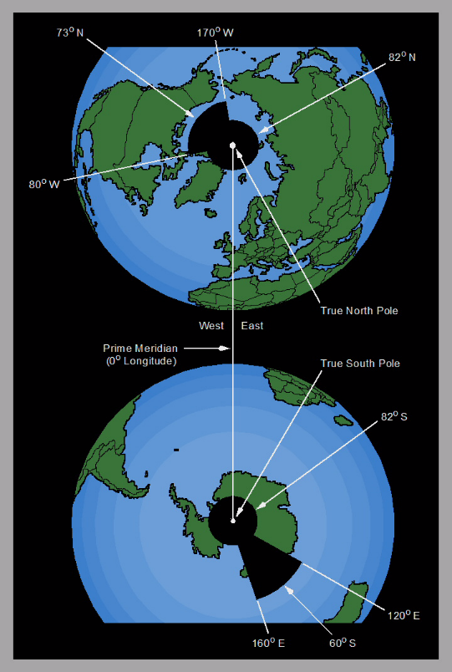

Figure 6 – Magnetic/True selection

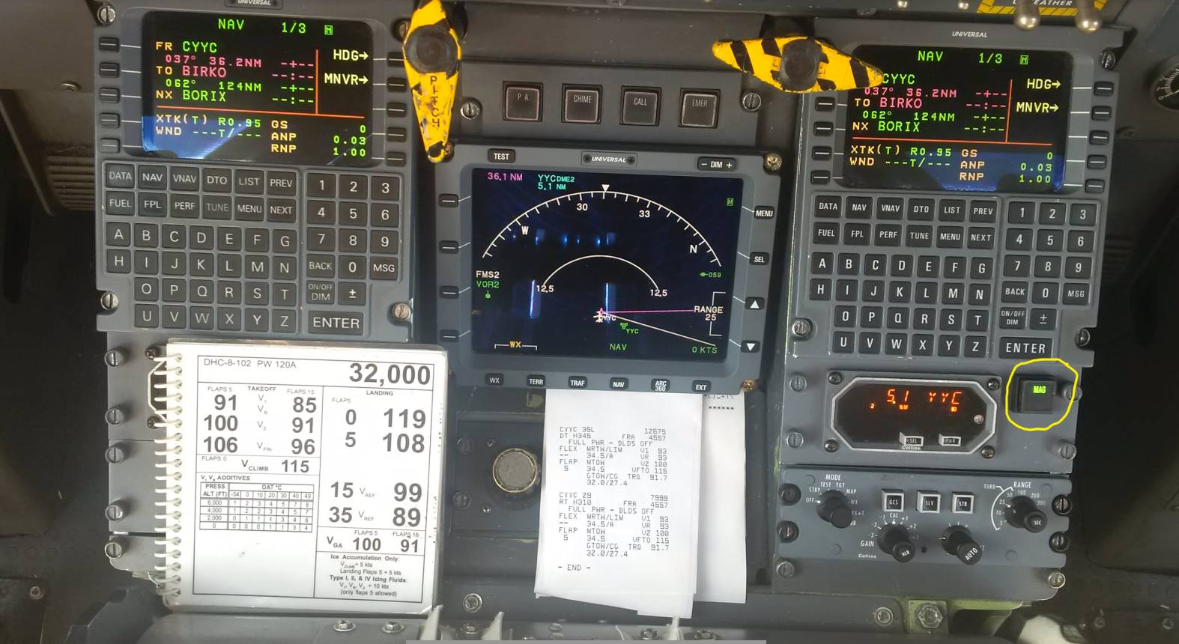



Figure 7 – Mag/True annunciator and switch (yellow circle) and text from aircraft flight manual supplement

## Aircraft that do not have an AFM option or AFM supplement certified and available rendering navigation systems incapable of operating in True

### Aircraft that are inertial equipped but do not currently have means to bypass mag var tables

Many larger aircraft introduced into service less than about 35 years ago use an inertial navigation gyro-based system for navigation. Two, or sometimes three, inertial reference systems determine True heading by measuring the direction of the Earth’s spin. In modern Flight Management Systems, all the navigation computations of spherical trigonometry to calculate desired tracks and all the computations of position data in latitude and longitude are carried out in True, so, for purely navigational purposes, there is no requirement for magnetic direction. Therefore, no magnetic sensor, or flux valve, is incorporated into the system.

However, for compatibility with air traffic control procedures, the aircraft must be capable of operating in magnetic. Thus, the inertial reference system contains a database with values of variation against latitude and longitude. Note that this is the reverse of the traditional situation, in which Magnetic heading was sensed and variation was used to convert it to True for navigation. Here, True is sensed, and variation is used to convert it to a computed magnetic heading.

Changing the magnetic variation tables within the FMS and procedure designs to read zero degrees east or zero degrees west across all of Canada for these aircraft will allow the aircraft to operate using True azimuth.

### Aircraft with a gyro-magnetic compass

Aircraft that use a traditional gyro-magnetic compass, or ones using a flux valve, are sometime considered as mid-sized aircraft.

The problem of operating gyro-magnetic compasses in True has been dealt with before. During the ‘50s and ‘60s, compasses were magnetic, but automatic dead reckoning systems using Doppler needed their input to be in True to be compatible with a latitude and longitude graticule. Most compasses for large aircraft of that period had a facility for manual entry of variation to give a True read-out to the navigation equipment and, in many cases, to the actual compass dial, so that the pilot could fly True headings off the compass.

This facility tended to die out in gyro-magnetic compasses produced after about 1970 because the Doppler Ground Position Indicators had become digital by then and it was simpler to adjust the variation in the display computer itself, rather than in the compass. However, if we switched to True, the demand would revive, and it would be an easy matter for manufacturers to reinstate a well-established fifty-year old technology into modern gyro-magnetic compasses.

The challenge is most current aircraft use a magnetic sense to feed the Attitude Heading Reference System (AHRS). One regional airline in Canada has been searching for options to do this based on AHRS obsolescence and associated repair costs. Low wing aircraft (such as Bombardier CRJs) have had issues with flux valves and interference from rebar in runways where they must depart in free gyro mode (such as happened at the KORD airport in the US). The addition of an inertial reference unit to replace a current AHRS would also be the foundation for Required Navigation Performance Authorization Required (RNP AR) operations, or these aircraft could switch to non-magnetic based systems or use a low-cost converter between the AHRS and the avionics bus. Many non-flux valve AHRS systems are now available using FOG (Fibre Optic Gyros) or (MEMS) (Micro-Electro-Mechanical Systems) which are competitively costed compared to traditional magnetic stabilized AHRS.

Newer systems designed and delivered by one large avionics manufacturer incorporate the ability for GA and Part 23 certified aircraft to actively switch back and forth between MAG and TRUE.

Another option being explored with a STC service provider for legacy systems is to place low-cost convertors between the AHRS unit and the Avionics Bus thereby converting MAG to TRUE allowing all aircraft systems to reference a TRUE HEADING at source.

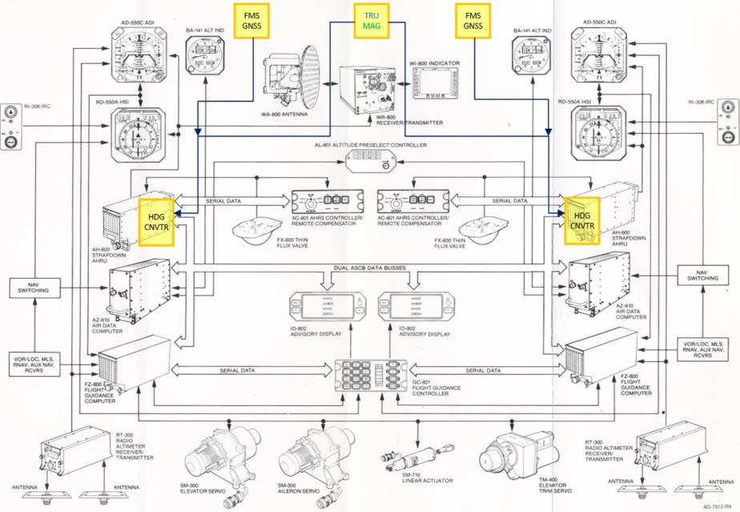

### Aircraft with Directional Gyros manually reset to a Direct Reading Compass

A Directional Gyro (DG) has no direct magnetic input and is simply set by the pilot to whatever datum is required. Normally, this is magnetic direction. All that would be required from the pilot is to apply the local variation every time that he/she resets the DG, normally done every fifteen minutes. Pilots are accustomed to applying factors to DG settings as they already incorporate the aircraft’s magnetic deviation from the aircraft compass card into the DG setting.

Pilots operating under Visual Flight Rules (VFR) technically still use track/drift lines on paper navigation charts, although many nowadays use Global Positioning System (GPS) with an electronic moving map.

Most IFR procedures are now track based, except for vectors, NDB instrument approach procedures, heading based legs in vector Standard Instrument Departures (SIDs) and some downwind legs on Standard Terminal Arrival (STAR) procedures. Pilots operating aircraft under Instrument flight Rules (IFR) would need to have a procedure to deal with variation between the heading observation from the wet compass to setting the DG. Figure 8 shows a typical IFR flight log and the steps to calculate True Course (TC), True Heading (TH), Magnetic Heading (MH) and Compass Heading (CH). Deviation is currently added at the aircraft level with the use of a compass deviation card. Variation that may need to be added or subtracted from an observed compass heading when resetting a Directional Gyro could be performed in the reverse manner.

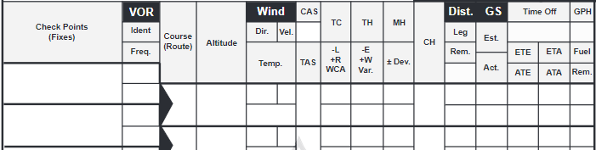

**Figure 8 – Example IFR flight log, showing steps to calculate True Course (TC), True Heading (TH), Magnetic Heading (MH) and Compass Heading (CH)**

As part any new pilots training, one of the first tasks learned in ground school is the working of a flight computer. These flight computers have a simple East/West variation slide rule on the wind side of the calculator from converting magnetic to true.

**Figure 9 – Example analogue flight computer. If the magnetic heading was 262, and the variation was 18 degrees east, after aligning those two values the TRUE HEADING is read at TC as 280. Set the DG to 280.**

### Aircraft with a Direct Reading Compass only

For aircraft that have nothing but a magnetic compass, the only real option would be to mentally apply variation or use the analogue flight computer. These aircraft operate exclusively VFR, and generally tend not to fly very far from their home bases; it would be a simple matter to remember just one value of variation and apply it every time. Or, Electronic Flight Bag Apps could be used as an intermediate step for corrections.

# Operational Impacts

This section describes the operational impacts of the proposed system on the various stakeholders. It may also describe the temporary impacts on stakeholders during the period when the new system is being developed or enabled.

Operational Impact Map:



Clicking the link to the file above will open a HTML rendering of the Operational Impact Mind Map

The stakeholders currently identified that may be impacted by the proposed system that need to be involved include:

NAV CANADA internal stakeholders:

* ATS Standards
* ATS System Integration
* ATS Service Delivery
* Level of Service
* Operational Training
* Safety and Quality
* AIM
* Technology
* Stakeholder and Commercial Relations
* Information Management
* Legal
* Communications and Public Affairs

Other Canadian stakeholders:

* Transport Canada
* Air operators
  + Flight Training Unit (FTU) certificate holders
  + Private Operator Registration Document (PORD) holders
  + Air Operator Certificate (AOC) holders
  + General Aviation
* Airport Authorities
* Other government agencies
* Other external stakeholders
* DND/RCAF

Foreign and other stakeholders:

* Adjacent ANSPs
* ICAO
* IATA
* Foreign military agencies
* Foreign Air Operators

This section provides operational impact information in order to allow all affected organisations to prepare for the changes that will be brought about by the new system and to allow for planning of the impacts on the various stakeholders during the development of, and transition to the new system.

# Financial Impacts

This section describes the financial impacts of the proposed system on the various stakeholders.

### Aircraft Operators

Within the aircraft operator categories there are three categories of aircraft that need to be considered.

1. Aircraft with Inertial Reference Units and FMS systems that can operate in True today. These aircraft should be able to transition to True with minimal additional expense limited to the enabling of unused aircraft options if True is not currently enabled.
2. Aircraft with Magnetic Sensing input to AHRS for magnetic heading output. This class of aircraft may or may not have an FMS that is capable of True North procedures but lacks a True heading input. Four options exist for this class of aircraft.
   1. Free Gyro Mode converting magnetic compass bearing to True and setting manually (not recommended)
   2. True heading converter that converts the magnetic AHRS heading output to True prior to use by the avionics bus or direct entry into the slaved directional gyro (assessed as low cost, no operational enhancements over baseline)
   3. Upgrade current AHRS to a north seeking AHRU. (assessed as medium cost, no operational enhancements over baseline)
   4. Upgrade current AHRS to a north seeking IRU (assessed as high cost, operational enhancements over baseline such as RNP AR capability)

### Airport Operators

Within the airport operators category the impact will range from low impact for airports near the 0° isogonal line only needing to update documentation but requiring no physical change to airports with medium near term impact requiring documentation change and physical change to runway numbering and airfield signage to realign runways to True. This one-time cost to change impact is a timing variance as airports that are currently far from the 0° isogonal line will require multiple changes in the future as the magnetic pole moves location and the local variation changes.

The following table shows a list of all hard surface runways in Canada and what the change impact to them would be. The vast majority of the runways are less than 6000 feet in length which will limit the financial impact somewhat given less access points to a 6000’ runway vs a 10000’ runway at a major airport.

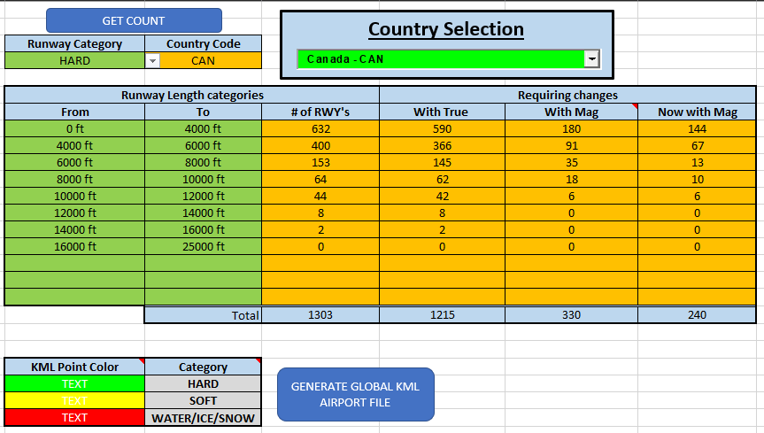

The next table shows the impact to soft surface Canadian runways. As no surface runway markings exist and these runways have limited taxiways, financial impacts would be limited to taxi/runway signs and documentation. Many non-certified aerodromes with soft surface runways have no signage which limits the financial impact to documentation.

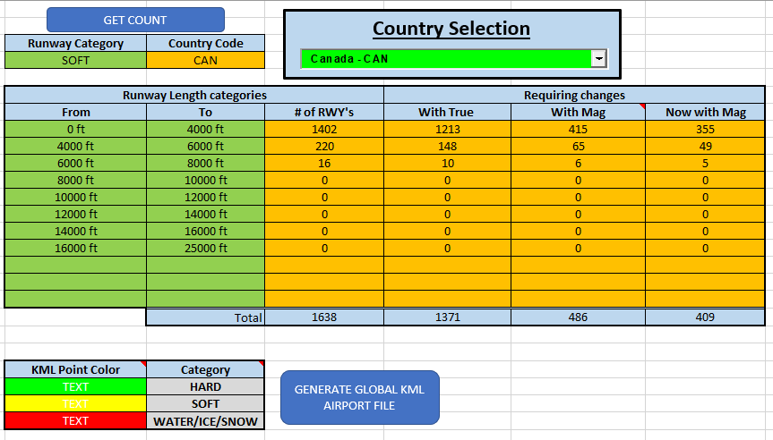

The next table shows the impact to water/ice/snow runways in Canada. These take-off and landing surfaces have no signage which limits the financial impact to documentation.

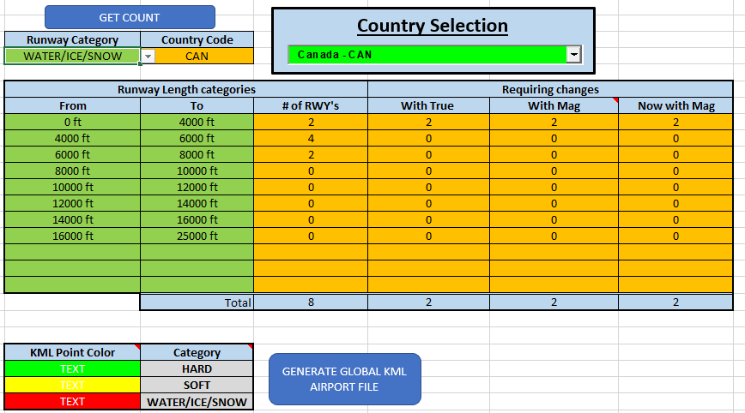

### Air Navigation Service Providers

In the following table is listed the magnetic variation used to set the declination of the 119 VORs currently in use in Canada as on November 2021. With the VOR MON project and VOR replacement program the approximately 65 new doppler VORs (to be complete within the 2030 timeframe) will be able to be adjusted for 0° declination fully electronically. The current VOR fleet typically had ±8-10° of electronic adjustment and the any adjustment more than this requires a physical rotation of the navigation aid.

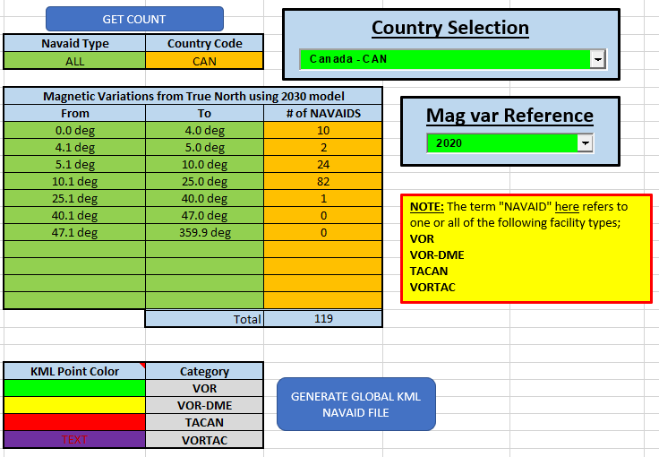

ANSPs would be required to amend publications and stop converting True Calculations to magnetic bearings, headings and tracks in the final stages of procedure design. Data systems used in the construction of procedures currently contain the True data but magnetic variation will need to be listed as 0 or removed. Overall financial impact could be minimized by using the current AIM staff to process the change in lieu of creating new procedures during the transition period.

### Avionics Original Equipment Manufactures

Avionics OEMs have been transitioning to non-magnetic seeking AHRU platforms over the last number of years and the financial impacts for these systems is in line with current costs for traditional magnetic seeking AHRU. For GA aircraft, and other light medium business aircraft, Garmin is capable of True North Operations today within their FMS/GPS navigation systems and databases and their AHRU when GPS aided is True North ready today. Forward fit systems are in development and available between 2026 and 2028.

Legacy systems would require retrofit via upgrade to new non-magnetic systems or the inclusion of heading convertors after the AHRU prior to the heading signal being broadcast on the avionics bus or directly input to the directional gyro.

With products in development, avionics OEMs would see a shift to their newer products within the 2030 timeline.

### Aircraft Manufactures

Aircraft manufactures would need to adjust aircraft flight manuals and operational data manuals to describe true north navigation, switch selection and data requirements with a careful eye to procedures during the transition period. This work would be done in concert with the avionics OEMs supplying equipment to the airframer.

### ICAO

ICAO would need to amend SARPs within the Annex’s and PANS documents to reflect a True North alignment system versus a Magnetic Alignment. Full documented changes to reference paragraphs are attached in the appendices highlighting the Canadian context.

### State Regulators

Much like ANSPs and OEMs, documentation and regulation may require amendment to enable a true alignment within Canada. While the only regulation focused on magnetic source is the alignment of the aircrafts standby compass, regulations that enable ICAO Annex’s require review.

### Aviation Database suppliers

Navigation system database suppliers and consolidators only process data delivered from the state AIP. This change would amend all Canadian data in southern domestic airspace over a defined period for release on a specific AIRAC date.

# Requirements

This section describes the list of specific requirements that must be addressed in order to implement the proposed system.

## Canadian Regulatory Requirements

Considering Canadian Northern Domestic Airspace already stipulates the use of True tracks for navigation, there would be no new regulatory requirement to expand the area where True is used for navigation. Minor CAR wording changes may be required to remove reference to use of magnetic azimuth, or to clarify that the proposed system uses True entirely.

## Domestic ANSP/ATM Requirements

As the primary domestic Air Navigation Service Provider (ANSP), NAV CANADA will need to modify numerous manuals and publications to reflect the proposed system, and training for ATS personnel will be required across the country. Coordination will also be required with the Department of National Defence (DND) where they provide services including air traffic control and ground-based navigation aids.

## Adjacent ANSP/ATM Requirements

NAV CANADA will need to coordinate extensively with the FAA to determine appropriate procedures and establish any mitigations required. Procedures in airspace where air traffic control services have been delegated to the adjacent ANSP will require particular consideration.

## Transition Requirements Between True/Magnetic Airspace

Having a transition is not as unprecedented as it sounds. Some countries use feet as the unit for altitude others use metres. Some use hectopascals as the unit for atmospheric pressure, others use inches of mercury and so on. There is no difference in principle if some were to use Magnetic and others to use True, but considerable education will be necessary.

Some aircraft systems assign a ‘gender’ to the flight data element used in the FMS database and compares the current mode of operation against the gender (mag or true) of the TO waypoint. Where the current mode of operation is different than the TO waypoint, the FMS generates a *CHECK HEADING REFERENCE* amber message. This, or some other method of differentiating airspace would be required if a country or a region were to go to TRUE alone or even as a best practise while managing a regional or hemispheric transition. Flight management systems today generate messages when operating in defined airspace by latitude and longitude I.E. *OCEANIC* operations. Going forward, mag/true airspaces could be as easily defined along with the PBN requirement for a set volume of airspace (RNP-10, RNP-4 etc).

## Communication, Navigation and Surveillance Requirements

The variation at a VOR is set at the ground station. It can be altered easily by changing the reference signal and, in fact, at present it has to be adjusted every time there is a variation change. So, the capability is already there to change it from Magnetic to True North. Once set, unlike the present situation, it would not need to be moved again. All Canadian VORs would be required to be rotated to a 0° declination, and procedures will need to be coordinated for radials that may be used across Canadian boundaries. The current fleet of VORs have 8 to 10 degrees of electronic adjustment available. The new fleet of Doppler VORs replacing the current aging fleet is 100% electronically adjustable to set declination.

Surveillance systems would need to be recalibrated to use True North through modification of the magnetic variation look-up tables currently in use. Cross-border surveillance sources would require specific consideration to ensure relative position to the radar source is accounted for if using range/bearing lines between aircraft pairs when operating in areas with high magnetic variation from the 0° isogonal line.

Mode S ES used for ADSB currently contains a MAG/TRUE indicator for aircraft heading output in the HRD message allow for air traffic to know if an aircraft is in the proper heading mode for a given volume of airspace.

## Airspace Requirements

True north will result in no new airspace requirements.

## Airport Requirements

Airports east and west of the ±10° W/E variation may be required to renumber their runways to account for the True reference. Considerable coordination with airport authorities would be required.

Areas shaded green are currently designated as TRUE NORTH operations. Yellow is ±4°, Magenta is ±10°

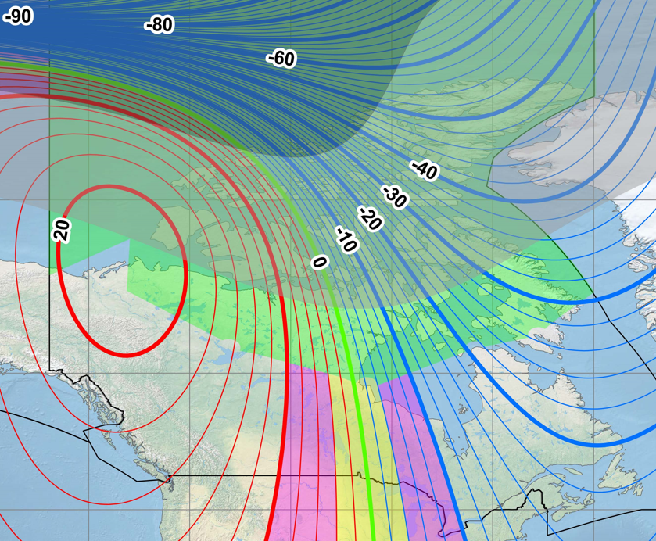

Figure 6 – Magnetic Variation in Canada

## Publication requirements

All instrument procedures designed by NAV CANADA are designed in True and magnetic variation values are added prior to publication. These values could be set to 0° and thereby reference True North. The volume of changes required would be considerable, and a phased implementation program across multiple AIRAC cycles may be required or NAV Canada Aeronautical Information Management could stop any new work for a six month period to convert the current procedure inventory back to True at chart assembly with one targeted AIRAC date for release.

## Weather Reporting Requirements

Current weather reports

## Customer/Stakeholder Requirements

Aircraft 424 databases could remain in their current format and structure with all Magnetic Variation values coded as 0°W or 0°E as desired with the heading output from the IRU set to True. Inertial reference unit equipped aircraft would be operated with reference to True via the existing or enabled “IRU True/MAG” selection.

Mid-sized aircraft operators may see benefits of changing to Attitude Heading Reference Systems (AHRS) that do not rely on flux valves and magnetic alignment and offer lower life cycle costs with additional operational capability. Some AHRS aircraft have availability to add a cost-effective converter between the AHRS and the avionics bus or directional gyros to operate in True. Aircraft avionics manufactures have provided briefings on new AHRS that will be available in the 2028 timeframe that do not depend on magnetic seeking flux valves. They either operate as north seeking like an IRU or they are GPS aided to adjust to True. Garmin has current capability to operate in True for its FMS systems as well as its ARHS if integrated.

Light aircraft with manually set directional gyros will need to set runway heading prior to departure and add or subtract variation from the magnetic compass reading prior to setting the DG. This could be done using simple mental match or using an analogue flight computer.

GPS systems operate in True and use magnetic variation tables to display magnetic bearings. These values could be set to 0°W or 0°E as desired like with a fully integrated FMS.

## Other External Stakeholder Requirements

Other external stakeholder requirements may be identified for the Canadian Department of National Defence (DND), the US Department of Defence (DOD) and NATO. Consultation will be required with these organizations. Aircraft utilizing mission equipment that require a heading reference will need to be assessed for True heading impact to determine if azimuth seeking to targets is relative to the aircraft or earth.

## International/ICAO Requirements

Canada would need to file additional ICAO Differences to SARPs for both Annex’s and PANS, which would include the use of True azimuth in both Northern and Southern Domestic Airspace.

# Analysis of Proposed System

Operating both Northern and Southern Domestic Airspace with reference to True would eliminate cost from the ANSP, Aircraft Operators, Airport Operators, Certification and Database providers and simplify navigation systems through the elimination of uncoordinated magnetic variation changes.

Modern performance-based navigation and conventional operations have been proven in Canadian Northern Domestic Airspace using a True reference system.

NAV CANADA has conducted a conversion test in Canadian Southern Domestic Airspace to prove conversion to True on a single database cycle was possible. Jeppesen was asked to amend NAV CANADA’s flight test database to show magnetic variation of ’00’ within the 424 FMS database for a flight test area in eastern Canada. A full mix of conventional and PBN procedures were successfully flown with no off nominal events observed with this database active and the IRU selected to True.

## Summary of Advantages

There are many advantages in moving to True, including simplifying technical processes for ground and air navigation systems. The change will require a high degree of planning and coordination and will carry risks that need to be managed. The end state however will be one with fewer systemic and latent safety risks to the aviation eco system.

Because magnetic north is always moving, all the procedures and systems built upon magnetic north need to be constantly updated and amended. Switching to True will therefore remove the cost involved for airlines in updating magnetic variation in inertial reference units (usually two or three per aircraft), flight management systems and other systems (like mission system for military or special flight operations) where installed.

Similarly, for ANSPs, switching to True removes the time devoted to updating approach and enroute procedures with the latest magnetic values. The system would be settle on a stationary value of 0° variation or True.

Airports meanwhile would never need to change runway numbering again. Given the documentation involved in that process, it would be a significant gain for this component of the aviation system.

Perhaps the biggest advantage to True is that it can be implemented by simply stopping a process – the conversion to magnetic north. As noted, inertial reference units on modern aircraft already function in True. Most modern inertially equipped aircraft have a MAG/TRUE switch that would just need to be selected for the area of operation during the transition. In a future state, aircraft and surveillance systems design could be simplified.

General aviation aircraft equipped with only a magnetic compass or magnetic sense system would need to either manually do a small conversion on what was read off of the magnetic compass prior to setting the directional gyro or use a conversion device that would convert from magnetic to True for them as currently demonstrated by a major GA avionics equipment manufacturer.

In 2018 it costs NAV CANADA roughly $500,000 per year to manage magnetic variation in various publications. Another $300,000 per year is spent rotating VORs and flight checking modified instrument procedures for magnetic variation changes. While Canada is large in landmass it has fewer procedures than an ANSP like the FAA and those under the EuroControl or ASECNA umbrellas. The cost savings for those organizations would scale to their procedure design catalogue.

Additional advantages include:

* Reduction of airport data, signage and runway renumbering requirements (once the proposed system has been implemented)
* Reduced surveillance system alignments
* Reduction in cost for aircraft magnetic variation table updates for inertial reference units and flight management systems (required every five years). One aircraft operator reported 2016 costs of $21 million for a fleet of 200 aircraft, another aircraft operator reported $1.2 million for a single fleet type of 32 aircraft, and NAV CANADA spent $500,000 during one magnetic variation cycle to update a flight inspection Bombardier DH8-100. These costs may lie directly with the aircraft operator, lessor, embedded in a purchase agreement or covered under an avionics maintenance plan/agreement but they are costs that eventually roll up to the end user.
* Reduced industry standards meetings and certification efforts to deal with the current magnetic variation issues affecting the worldwide fleet, including database inconsistencies, loss of ILS Category II/III certification, etc.
* Greenhouse gases reduced to 0 for VOR rotations and airway flight checks
* No loss of services due to procedures being NOTAM’ed out of service for magnetic variation issues
* No loss of CAT II/III services due to mag var differences
* Reduced instrument procedure maintenance

## Summary of Disadvantages or Limitations

Airports that that will have their runway numbering affected by the requirement to align to the nearest 10 degrees to the heading system used may require change when comparing the current magnetic heading to the True heading. As all airports will eventually require change due to moving magnetic variation values this cost to change to True will become a timing variance for the airport. Planned properly during the declared transition period, costs can be reduced by combining the change with airport routine maintenance activities. Data and signage would never need to change again due to magnetic variation.

In Canada it is estimated that airport costs would be approximately $10,000 per runway hold line, to cover new paint, signage and any data expense. Large airports such as Toronto International could expect costs around $1.1 million, medium-sized airports such as Halifax International might cost approximately $150,000 while small airports like Deer Lake Regional would experience costs around $40,000. Airports in Central Canada near the 0° isogonal would not require any change. Airports with dual, triple, or quad runway operations may not need to change every runway number owing to the fact that current selected runway numbers for some runways for those configurations may be more closely aligned to the True heading versus the current magnetic heading.

Aircraft operators with inertial reference units would need to enable the MAG/TRUE functions if they not currently active, which might result in a one-time cost and aircraft operators that operate with a magnetically slaved AHRS would also experience a one-time cost to instal certified converters or newer north sensing ARHS that do not require a magnetic sense.

# Appendices

Annex analysis

Current Canadian filed differences with ICAO